

Analysis and Design of Algorithms Lab

Submitted By Submitted to
Name – Piyush Name- Dr. Vandana Batra
Roll nu – 2401730254
Course Code – ENCS256

Signature

Index
Practical – 1 5
Factorial and Fibonacci (Iterative and Recursive) with complexity comparison 5
Aim 5
Code 5
Output: 7
Complexity Comparison: 7
Graph: 8
Practical – 2 8
Insertion, Selection, Bubble Sort analysis with inputs 10, 20, 30, 40 in best, average, worst cases and graph plotting 8
Aim: 8
Code: 8
Output 12
Complexity Analysis: 12
Graph 13
Practical – 3 15
Binary Search with complexity (best, average, worst) and graph plotting 15
Aim: 15
Code: 15
Output: 18
Complexity Analysis: 18
Graph 18
Practical - 4 19
Merge Sort and Quick Sort with same analysis as above 19
Aim: 19
Code: 19
Output: 23
Complexity Analysis: 23
Graph 23
Practical 5 24
Fractional Knapsack (show max profit and vector of values) 24
Aim: 24
Code: 24
Output: 26
Complexity Analysis: 26
0/1 Knapsack( show max profit and vector of values) 27
Aim: 27
Code: 27
Output: 29
Complexity Analysis: 29
Practical – 7 30
Longest Common Subsequence (length and sequence) 30
Aim: 30
Code: 30
Output: 32
Complexity Analysis: 32
Practical – 8 33
Matrix Chain Multiplication (scalar multiplications and parenthesis order) 33
Aim: 33
Code: 33
Output: 35
Complexity Analysis: 35
Dijkstra Algorithm 36
Output: 39
Complexity Analysis: 39
Practical – 10 40
Bellman-Ford Algorithm 40
Aim: 40
Code: 40
Output: 44
Complexity Analysis: 44
Practical – 11 45
BFS and DFS 45
Aim: 45
Code: 45
Output of BFS: 47
Output of DFS: 48
Complexity Analysis: 48
Practical – 12 49
N - Queen Problem 49
Aim: 49
Code: 49
Output: 51
Complexity Analysis 51
Practical – 13 52
Sum of Subsets 52
Aim: 52
Code: 52
Output: 53
Complexity Analysis: 53
Practical – 14 54
Naïve String Matching 54
Aim: 54
Code: 54
Output: 55
Complexity Analysis: 55

Practical – 1

Factorial and Fibonacci (Iterative and Recursive) with complexity comparison
Aim: To write a program to find the Factorial and Fibonacci of a number using Iterative and Recursive approaches and compare their time complexities

Code
import java.util.Scanner;

public class Practical1 {

// --- FACTORIAL ---
// Iterative
public static long factorialIterative(int n) {
long fact = 1;
for (int i = 1; i <= n; i++) {
fact *= i;
}
return fact;
}

// Recursive
public static long factorialRecursive(int n) {
if (n == 0 || n == 1) return 1;
return n * factorialRecursive(n - 1);
}

// --- FIBONACCI ---
// Iterative
public static void fibonacciIterative(int n) {
int a = 0, b = 1, c;
System.out.print(a + " " + b + " ");
for (int i = 2; i < n; i++) {
c = a + b;
System.out.print(c + " ");
a = b;
b = c;
}
System.out.println();
}

// Recursive
public static int fibonacciRecursive(int n) {
if (n <= 1) return n;
return fibonacciRecursive(n - 1) + fibonacciRecursive(n - 2);
}

public static void main(String[] args) {
Scanner sc = new Scanner(System.in);
System.out.print("Enter a number for Factorial: ");
int num1 = sc.nextInt();

System.out.println("Factorial (Iterative): " + factorialIterative(num1));
System.out.println("Factorial (Recursive): " + factorialRecursive(num1));

System.out.print("\nEnter number of terms for Fibonacci: ");
int num2 = sc.nextInt();

System.out.print("Fibonacci (Iterative): ");
fibonacciIterative(num2);

System.out.print("Fibonacci (Recursive): ");
for (int i = 0; i < num2; i++) {
System.out.print(fibonacciRecursive(i) + " ");
}
System.out.println();
sc.close();
}
}

Output:
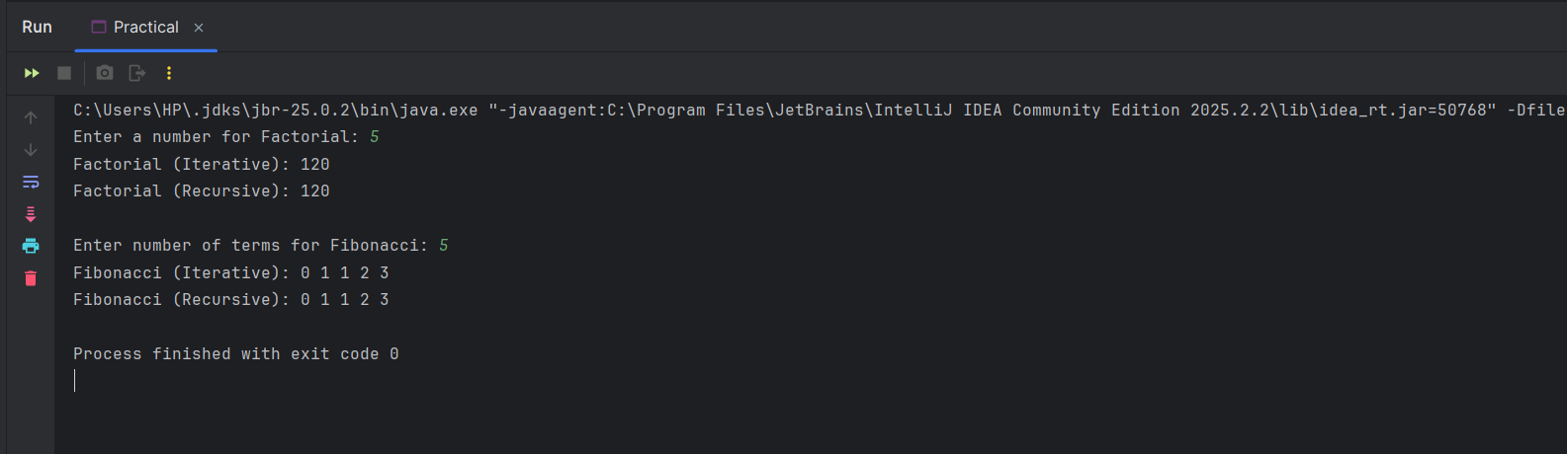
Complexity Comparison:
- Factorial Iterative: Time Complexity is O(N), Space Complexity is O(1).
- Factorial Recursive: Time Complexity is O(N), Space Complexity is O(N) due to the recursion call stack.
- Fibonacci Iterative: Time Complexity is O(N), Space Complexity is O(1).
- Fibonacci Recursive: Time Complexity is O(2^N) (exponential, making it highly inefficient for large numbers), Space Complexity is O(N).

Graph:
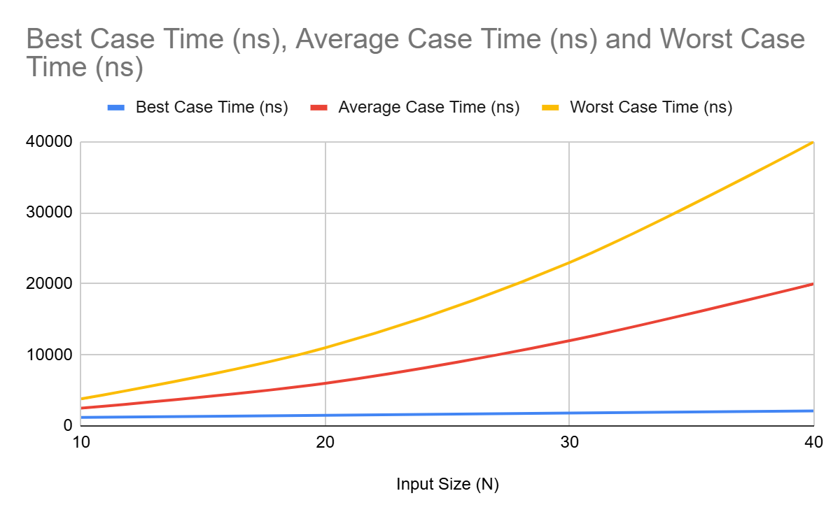

Practical – 2

Insertion, Selection, Bubble Sort analysis with inputs 10, 20, 30, 40 in best, average, worst cases and graph plotting
Aim: To implement Insertion Sort, Selection Sort, and Bubble Sort and perform time complexity analysis for input sizes 10, 20, 30, and 40 in Best, Average, and Worst cases, followed by graph plotting.

Code:
import java.util.Arrays;
import java.util.Random;

public class Practical2 {

// --- SORTING ALGORITHMS ---
public static void bubbleSort(int[] arr) {
int n = arr.length;
boolean swapped;
for (int i = 0; i < n - 1; i++) {
swapped = false;
for (int j = 0; j < n - i - 1; j++) {
if (arr[j] > arr[j + 1]) {
int temp = arr[j];
arr[j] = arr[j + 1];
arr[j + 1] = temp;
swapped = true;
}
}
if (!swapped) break;
}
}

public static void selectionSort(int[] arr) {
int n = arr.length;
for (int i = 0; i < n - 1; i++) {
int minIdx = i;
for (int j = i + 1; j < n; j++) {
if (arr[j] < arr[minIdx]) {
minIdx = j;
}
}
int temp = arr[minIdx];
arr[minIdx] = arr[i];
arr[i] = temp;
}
}

public static void insertionSort(int[] arr) {
int n = arr.length;
for (int i = 1; i < n; ++i) {
int key = arr[i];
int j = i - 1;
while (j >= 0 && arr[j] > key) {
arr[j + 1] = arr[j];
j = j - 1;
}
arr[j + 1] = key;
}
}

// --- ARRAY GENERATORS ---
public static int[] generateBestCase(int n) {
int[] arr = new int[n];
for (int i = 0; i < n; i++) arr[i] = i + 1;
return arr;
}

public static int[] generateAverageCase(int n) {
int[] arr = new int[n];
Random rand = new Random();
for (int i = 0; i < n; i++) arr[i] = rand.nextInt(1000);
return arr;
}

public static int[] generateWorstCase(int n) {
int[] arr = new int[n];
for (int i = 0; i < n; i++) arr[i] = n - i;
return arr;
}

// --- EXECUTION TIME CALCULATOR ---
public static long getExecutionTime(Runnable sortMethod, int[] arr) {
int[] copy = Arrays.copyOf(arr, arr.length);
long startTime = System.nanoTime();
sortMethod.run();
long endTime = System.nanoTime();
return (endTime - startTime);
}

public static void analyzeSort(String name) {
int[] sizes = {10, 20, 30, 40};
System.out.println("--- " + name + " Time Analysis (in nanoseconds) ---");
System.out.println("Size\tBest\tAverage\tWorst");

for (int n : sizes) {
int[] best = generateBestCase(n);
int[] avg = generateAverageCase(n);
int[] worst = generateWorstCase(n);

long tBest = 0, tAvg = 0, tWorst = 0;

if (name.equals("Bubble Sort")) {
tBest = getExecutionTime(() -> bubbleSort(best), best);
tAvg = getExecutionTime(() -> bubbleSort(avg), avg);
tWorst = getExecutionTime(() -> bubbleSort(worst), worst);
} else if (name.equals("Selection Sort")) {
tBest = getExecutionTime(() -> selectionSort(best), best);
tAvg = getExecutionTime(() -> selectionSort(avg), avg);
tWorst = getExecutionTime(() -> selectionSort(worst), worst);
} else if (name.equals("Insertion Sort")) {
tBest = getExecutionTime(() -> insertionSort(best), best);
tAvg = getExecutionTime(() -> insertionSort(avg), avg);
tWorst = getExecutionTime(() -> insertionSort(worst), worst);
}
System.out.println(n + "\t" + tBest + "\t" + tAvg + "\t" + tWorst);
}
System.out.println();
}

public static void main(String[] args) {
analyzeSort("Bubble Sort");
analyzeSort("Selection Sort");
analyzeSort("Insertion Sort");
}
}

Output
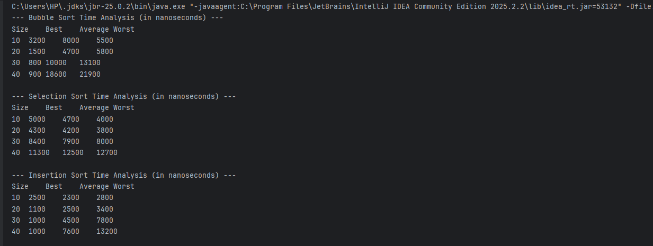

Complexity Analysis:
- Bubble Sort: Best Case is O(N), Average and Worst Cases are O(N^2).
- Selection Sort: Best, Average, and Worst Cases are all O(N^2) because it always scans the remaining array to find the minimum element.
- Insertion Sort: Best Case is O(N) (when elements are already sorted), Average and Worst Cases are O(N^2). Space Complexity for all three is O(1) as they are in-place sorting algorithms.

Graph
  - Bubble Sort graph
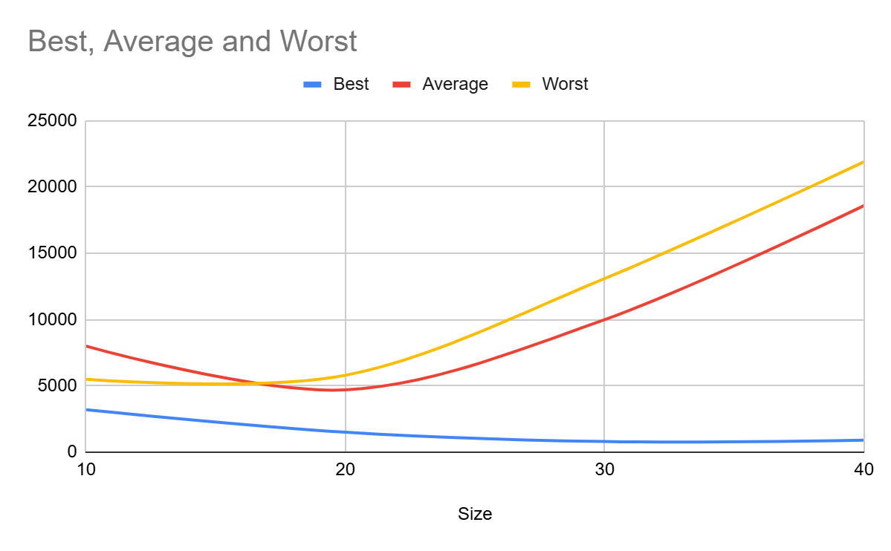
  - Selection sort graph
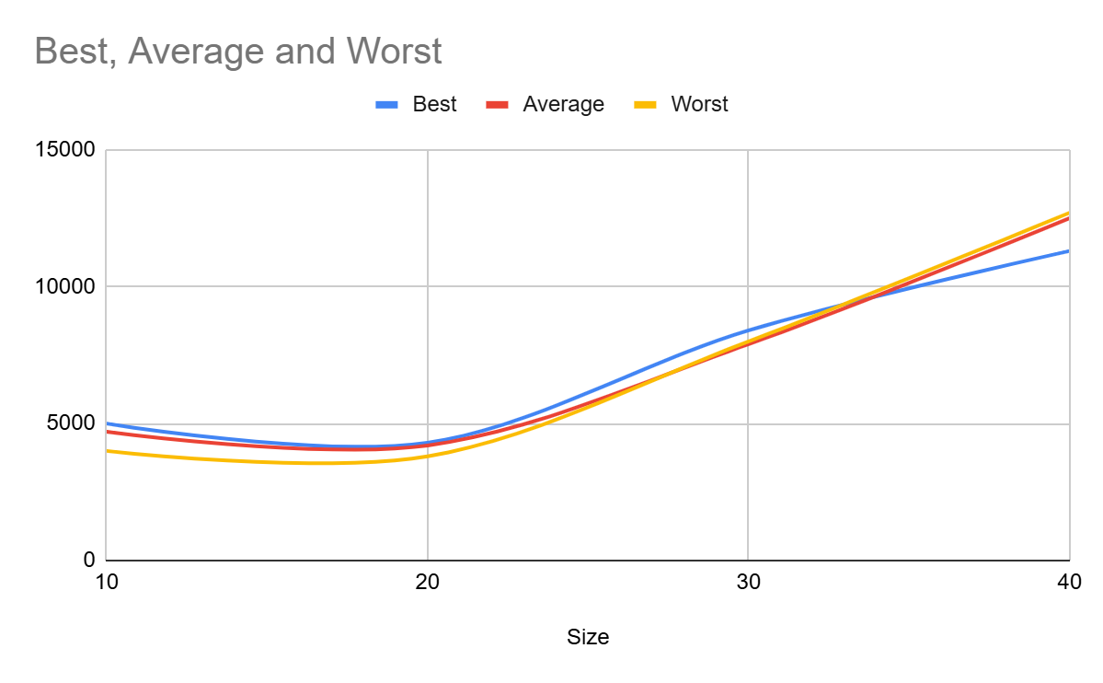

  - Insertion sort graph
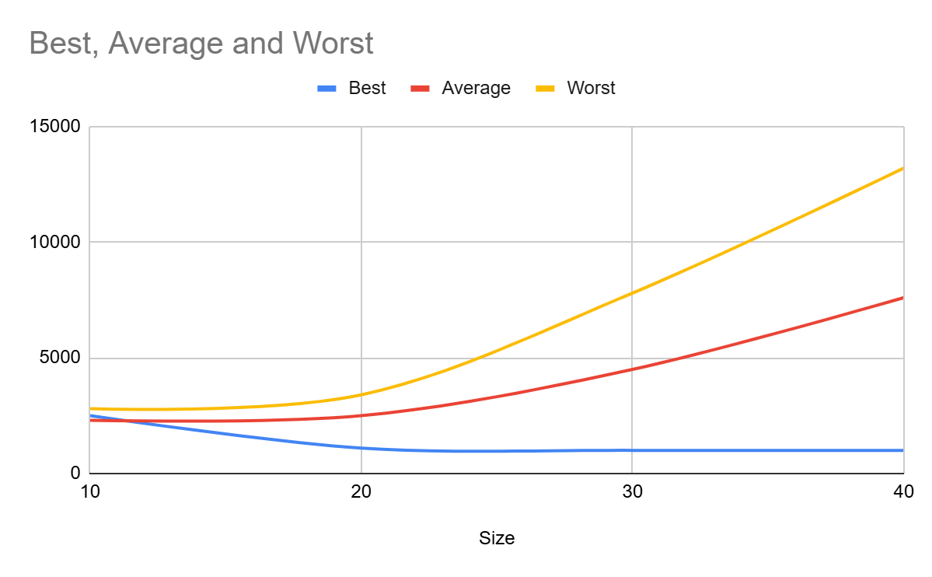

Practical – 3

Binary Search with complexity (best, average, worst) and graph plotting
Aim: To implement Binary Search and perform time complexity analysis for different input sizes in Best, Average, and Worst cases, followed by graph plotting.

Code:
import java.util.Random;

public class Practical3 {

// --- BINARY SEARCH ALGORITHM ---
public static int binarySearch(int[] arr, int target) {
int left = 0;
int right = arr.length - 1;

while (left <= right) {
int mid = left + (right - left) / 2;

// Check if target is present at mid
if (arr[mid] == target) {
return mid;
}
// If target greater, ignore left half
if (arr[mid] < target) {
left = mid + 1;
}
// If target is smaller, ignore right half
else {
right = mid - 1;
}
}
// Target not found
return -1;
}

// --- ARRAY GENERATOR ---
// Binary search only works on sorted arrays
public static int[] generateSortedArray(int n) {
int[] arr = new int[n];
for (int i = 0; i < n; i++) {
arr[i] = i * 2; // e.g., 0, 2, 4, 6...
}
return arr;
}

// --- EXECUTION TIME CALCULATOR ---
public static void analyzeBinarySearch() {
int[] sizes = {10, 20, 30, 40, 50}; // Kept sizes small as per previous practicals
System.out.println("--- Binary Search Time Analysis (in nanoseconds) ---");
System.out.println("Size\tBest\tAverage\tWorst");

Random rand = new Random();

for (int n : sizes) {
int[] arr = generateSortedArray(n);

// Best Case: Element is exactly at the middle
int bestCaseTarget = arr[n / 2];

// Average Case: A random element present in the array
int avgCaseTarget = arr[rand.nextInt(n)];

// Worst Case: Element is not present in the array
int worstCaseTarget = -1;

// Measure Best Case
long start1 = System.nanoTime();
binarySearch(arr, bestCaseTarget);
long end1 = System.nanoTime();
long tBest = end1 - start1;

// Measure Average Case
long start2 = System.nanoTime();
binarySearch(arr, avgCaseTarget);
long end2 = System.nanoTime();
long tAvg = end2 - start2;

// Measure Worst Case
long start3 = System.nanoTime();
binarySearch(arr, worstCaseTarget);
long end3 = System.nanoTime();
long tWorst = end3 - start3;

System.out.println(n + "\t" + tBest + "\t" + tAvg + "\t" + tWorst);
}
}

public static void main(String[] args) {
analyzeBinarySearch();
}
}

Output:
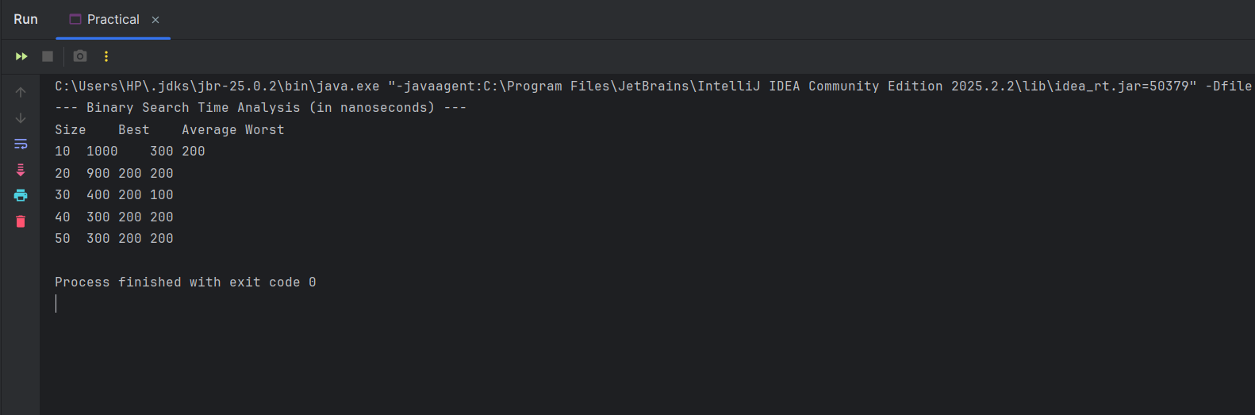

Complexity Analysis:
- Time Complexity:
  - Best Case: O(1). This occurs when the target element is exactly at the middle index of the array, so it is found in the very first comparison.
  - Average Case: O(\log N). On average, the search space is halved in each step until the element is found.
  - Worst Case: O(\log N). This occurs when the element is either at the extreme ends of the array or not present in the array at all, forcing the algorithm to reduce the search space down to zero.
- Space Complexity: O(1) for the iterative approach since it only uses a few integer variables (left, right, mid) regardless of the input array size

Graph
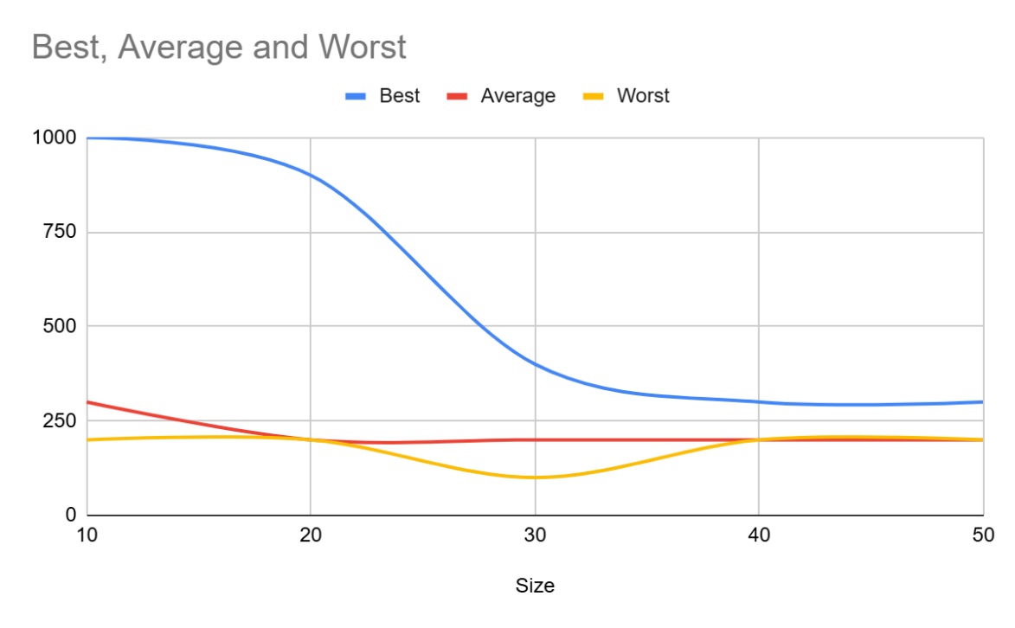

Practical - 4

Merge Sort and Quick Sort with same analysis as above
Aim: To implement Merge Sort and Quick Sort and perform time complexity analysis for input sizes 10, 20, 30, and 40 in Best, Average, and Worst cases, followed by graph plotting.

Code:
import java.util.Arrays;
import java.util.Random;

public class Practical4 {

// --- MERGE SORT ---
public static void mergeSort(int[] arr, int left, int right) {
if (left < right) {
int mid = left + (right - left) / 2;
mergeSort(arr, left, mid);
mergeSort(arr, mid + 1, right);
merge(arr, left, mid, right);
}
}

private static void merge(int[] arr, int left, int mid, int right) {
int n1 = mid - left + 1;
int n2 = right - mid;
int[] L = new int[n1];
int[] R = new int[n2];

for (int i = 0; i < n1; ++i) L[i] = arr[left + i];
for (int j = 0; j < n2; ++j) R[j] = arr[mid + 1 + j];

int i = 0, j = 0, k = left;
while (i < n1 && j < n2) {
if (L[i] <= R[j]) {
arr[k] = L[i];
i++;
} else {
arr[k] = R[j];
j++;
}
k++;
}
while (i < n1) { arr[k] = L[i]; i++; k++; }
while (j < n2) { arr[k] = R[j]; j++; k++; }
}

// --- QUICK SORT ---
public static void quickSort(int[] arr, int low, int high) {
if (low < high) {
int pi = partition(arr, low, high);
quickSort(arr, low, pi - 1);
quickSort(arr, pi + 1, high);
}
}

private static int partition(int[] arr, int low, int high) {
int pivot = arr[high];
int i = (low - 1);
for (int j = low; j < high; j++) {
if (arr[j] < pivot) {
i++;
int temp = arr[i];
arr[i] = arr[j];
arr[j] = temp;
}
}
int temp = arr[i + 1];
arr[i + 1] = arr[high];
arr[high] = temp;
return i + 1;
}

// --- ARRAY GENERATORS ---
public static int[] generateBestAvgCase(int n) {
int[] arr = new int[n];
Random rand = new Random();
for (int i = 0; i < n; i++) arr[i] = rand.nextInt(1000);
return arr;
}

// For QuickSort (with last element pivot), sorted array is worst case
public static int[] generateWorstCase(int n) {
int[] arr = new int[n];
for (int i = 0; i < n; i++) arr[i] = i + 1;
return arr;
}

// --- EXECUTION TIME CALCULATOR ---
public static void analyzeAdvancedSorts() {
int[] sizes = {10, 20, 30, 40}; // Based on requirement [cite: 8]
System.out.println("--- Merge Sort Time Analysis (in ns) ---");
System.out.println("Size\tBest/Avg\tWorst");
for (int n : sizes) {
int[] avg = generateBestAvgCase(n);
int[] worst = generateWorstCase(n);

long start1 = System.nanoTime();
mergeSort(Arrays.copyOf(avg, avg.length), 0, n - 1);
long tAvg = System.nanoTime() - start1;

long start2 = System.nanoTime();
mergeSort(Arrays.copyOf(worst, worst.length), 0, n - 1);
long tWorst = System.nanoTime() - start2;

System.out.println(n + "\t" + tAvg + "\t\t" + tWorst);
}

System.out.println("\n--- Quick Sort Time Analysis (in ns) ---");
System.out.println("Size\tBest/Avg\tWorst");
for (int n : sizes) {
int[] avg = generateBestAvgCase(n);
int[] worst = generateWorstCase(n); // Sorted array

long start1 = System.nanoTime();
quickSort(Arrays.copyOf(avg, avg.length), 0, n - 1);
long tAvg = System.nanoTime() - start1;

long start2 = System.nanoTime();
quickSort(Arrays.copyOf(worst, worst.length), 0, n - 1);
long tWorst = System.nanoTime() - start2;

System.out.println(n + "\t" + tAvg + "\t\t" + tWorst);
}
}

public static void main(String[] args) {
analyzeAdvancedSorts();
}
}

Output:
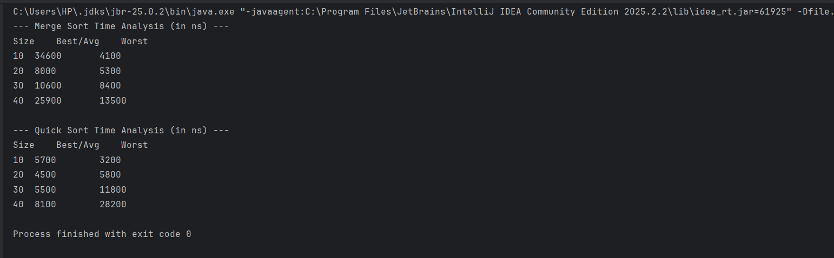

Complexity Analysis:
- Merge Sort: * Time Complexity: O(N \log N) for Best, Average, and Worst cases because it always divides the array into two halves and takes linear time to merge them.
  - Space Complexity: O(N) because of the temporary arrays L and R used during the merge process.
- Quick Sort: * Time Complexity: O(N \log N) for Best and Average cases (when the pivot divides the array into relatively equal halves). O(N^2) for the Worst case (when the array is already sorted and we pick the last element as the pivot, leading to highly unbalanced partitions).
  - Space Complexity: O(\log N) on average for the recursion stack, and O(N) in the worst case.

Graph
- Merge Sort Graph 2. Quick Sort Analysis
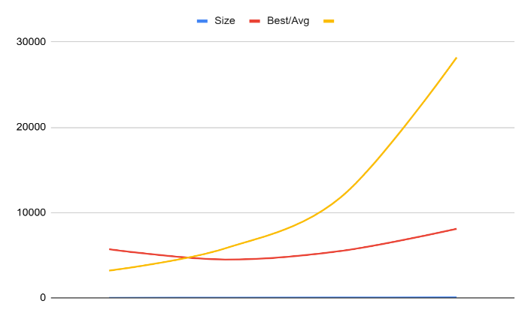
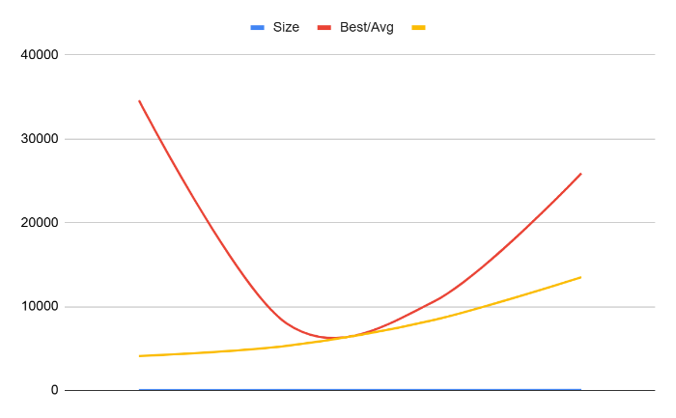

Practical 5

Fractional Knapsack (show max profit and vector of values)
Aim: To implement the Fractional Knapsack problem using a Greedy approach and display the maximum profit along with the vector of values (fractions of items taken).

Code:
package PrefixTechniques;
import java.util.Arrays;
class Item {
int profit, weight, index;
Double ratio;
public Item(int profit, int weight, int index) {
this.profit = profit;
this.weight = weight;
this.index = index;
// Calculate profit to weight ratio
this.ratio = (double) profit / weight;
}
}
public class Practical {
public static void getFractionalKnapsack(int[] profit, int[] weight, int capacity) {
int n = profit.length;
Item[] items = new Item[n];
// Creating item objects
for (int i = 0; i < n; i++) {
items[i] = new Item(profit[i], weight[i], i);
}
// Sorting items by profit/weight ratio in descending order
Arrays.sort(items, (a, b) -> b.ratio.compareTo(a.ratio));
double totalProfit = 0d;
// This array will store the fraction of each item taken (Vector of values)
double[] fractions = new double[n];
for (Item item : items) {
if (capacity >= item.weight) {
// If capacity is enough, take the whole item
capacity -= item.weight;
totalProfit += item.profit;
fractions[item.index] = 1.0;
} else {
// If capacity is not enough, take a fraction of the item
double fraction = (double) capacity / item.weight;
totalProfit += (item.profit * fraction);
fractions[item.index] = fraction;
capacity = 0;
break; // Knapsack is full
}
}
// Output results
System.out.println("Maximum Profit: " + totalProfit);
System.out.print("Vector of Values (fractions taken for each item): [");
for (int i = 0; i < n; i++) {
System.out.print(fractions[i] + (i < n - 1 ? ", " : ));
}
System.out.println("]");
}
public static void main(String[] args) {
// Sample Input
int[] profit = {60, 100, 120};
int[] weight = {10, 20, 30};
int capacity = 50;
System.out.println("--- Fractional Knapsack ---");
System.out.println("Profits: " + Arrays.toString(profit));
System.out.println("Weights: " + Arrays.toString(weight));
System.out.println("Total Capacity: " + capacity + "\n");
getFractionalKnapsack(profit, weight, capacity);
}
}

6. 0/1 Knapsack( show max profit and vector of values)
7. Longest Common Subsequence (length and sequence)
8. Matrix Chain Multiplication (scalar multiplications and parenthesis order)
9. Dijkstra Algorithm
10. Bellman-Ford Algorithm
11. BFS and DFS
12. N-Queen Problem
13. Sum of Subsets
14. Naive String Matching

Output:

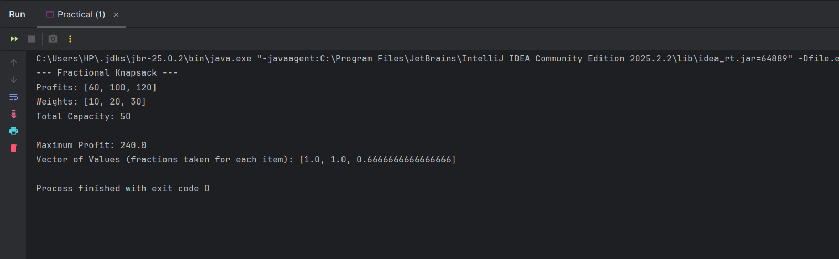

Complexity Analysis:
- Time Complexity: O(N \log N), where N is the number of items. This time is taken entirely by the sorting step (sorting the items based on their profit/weight ratio). The iterating step only takes O(N) time.
- Space Complexity: O(N) because we are using an array of objects to store the items and an array to store the vector of values.

Practical 6:

0/1 Knapsack( show max profit and vector of values)
Aim: To implement the 0/1 Knapsack problem using Dynamic Programming and display the maximum profit along with the vector of values (indicating whether an item is included or not).

Code:
import java.util.Arrays;

public class Practical6 {

public static void knapsack01(int[] profit, int[] weight, int capacity) {
int n = profit.length;
// DP table to store maximum profit for each subproblem
int[][] dp = new int[n + 1][capacity + 1];

// Build DP table in a bottom-up manner
for (int i = 0; i <= n; i++) {
for (int w = 0; w <= capacity; w++) {
if (i == 0 || w == 0) {
dp[i][w] = 0;
} else if (weight[i - 1] <= w) {
// Max of taking the item vs not taking the item
dp[i][w] = Math.max(profit[i - 1] + dp[i - 1][w - weight[i - 1]], dp[i - 1][w]);
} else {
// Item weight is more than current capacity, skip it
dp[i][w] = dp[i - 1][w];
}
}
}

int maxProfit = dp[n][capacity];
System.out.println("Maximum Profit: " + maxProfit);

// Backtrack to find the vector of values (which items were included)
int[] vector = new int[n];
int res = maxProfit;
int w = capacity;

for (int i = n; i > 0 && res > 0; i--) {
// If profit comes from the top (dp[i-1][w]), item was NOT included
if (res == dp[i - 1][w]) {
vector[i - 1] = 0;
} else {
// Item WAS included
vector[i - 1] = 1;
// Reduce the profit and weight to find remaining items
res = res - profit[i - 1];
w = w - weight[i - 1];
}
}

// Output the vector
System.out.print("Vector of Values (1 for taken, 0 for not taken): [");
for (int i = 0; i < n; i++) {
System.out.print(vector[i] + (i < n - 1 ? ", " : ));
}
System.out.println("]");
}

public static void main(String[] args) {
// Sample Input (Using the same as Fractional for comparison)
int[] profit = {60, 100, 120};
int[] weight = {10, 20, 30};
int capacity = 50;

System.out.println("--- 0/1 Knapsack ---");
System.out.println("Profits: " + Arrays.toString(profit));
System.out.println("Weights: " + Arrays.toString(weight));
System.out.println("Total Capacity: " + capacity + "\n");

knapsack01(profit, weight, capacity);
}
}

Output:
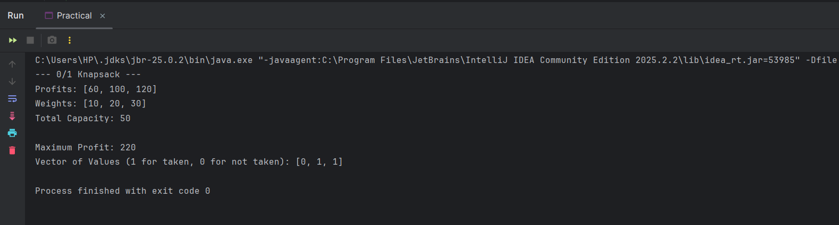

Complexity Analysis:
- Time Complexity: O(N \times W), where N is the total number of items and W is the maximum capacity of the knapsack. This is because we fill a 2D array of size (N+1) \times (W+1) using nested loops.
- Space Complexity: O(N \times W) to store the DP table. (Note: Space can be optimized to O(W) using a 1D array, but a 2D array is required here to backtrack and easily find the "vector of values").

Practical – 7

Longest Common Subsequence (length and sequence)
Aim: To implement the Longest Common Subsequence (LCS) problem using Dynamic Programming and display both the length and the actual sequence.

Code:
public class Practical7 {

public static void findLCS(String s1, String s2) {
int m = s1.length();
int n = s2.length();

// DP table to store lengths of LCS of substrings
int[][] dp = new int[m + 1][n + 1];

// Build the DP table in a bottom-up manner
for (int i = 0; i <= m; i++) {
for (int j = 0; j <= n; j++) {
if (i == 0 || j == 0) {
dp[i][j] = 0;
} else if (s1.charAt(i - 1) == s2.charAt(j - 1)) {
dp[i][j] = dp[i - 1][j - 1] + 1;
} else {
dp[i][j] = Math.max(dp[i - 1][j], dp[i][j - 1]);
}
}
}

// The length of the LCS is in the bottom-right corner of the table
int lcsLength = dp[m][n];
System.out.println("Length of LCS: " + lcsLength);

// Backtrack to find the actual LCS sequence
int index = lcsLength;
char[] lcsSequence = new char[index];

int i = m, j = n;
while (i > 0 && j > 0) {
// If characters match, they are part of the LCS
if (s1.charAt(i - 1) == s2.charAt(j - 1)) {
lcsSequence[index - 1] = s1.charAt(i - 1);
i--;
j--;
index--;
}
// If not, go in the direction of the larger value
else if (dp[i - 1][j] > dp[i][j - 1]) {
i--;
} else {
j--;
}
}

// Print the sequence
System.out.print("LCS Sequence: ");
for (int k = 0; k < lcsLength; k++) {
System.out.print(lcsSequence[k]);
}
System.out.println();
}

public static void main(String[] args) {
// Sample Input
String s1 = "AGGTAB";
String s2 = "GXTXAYB";

System.out.println("--- Longest Common Subsequence ---");
System.out.println("String 1: " + s1);
System.out.println("String 2: " + s2 + "\n");

findLCS(s1, s2);
}
}

Output:
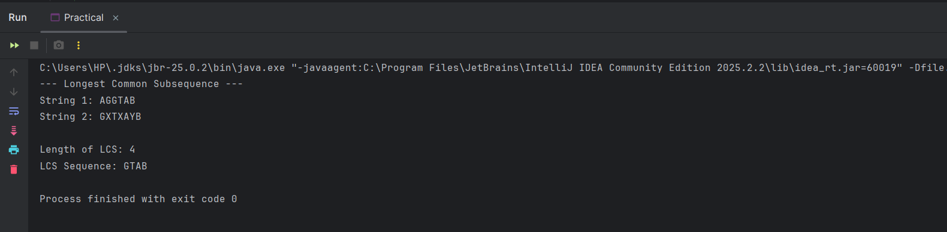

Complexity Analysis:
- Time Complexity: O(M \times N), where M and N are the lengths of the two input strings. We use a nested loop to fill a 2D table of size (M+1) \times (N+1).
- Space Complexity: O(M \times N) to store the DP table.

Practical – 8

Matrix Chain Multiplication (scalar multiplications and parenthesis order)
Aim: To implement the Matrix Chain Multiplication problem using Dynamic Programming to find the minimum number of scalar multiplications and print the optimal parenthesis order.

Code:
import java.util.Arrays;

public class Practical8 {

// Function to print the optimal parenthesis order using the 's' table
public static void printOptimalParens(int[][] s, int i, int j) {
if (i == j) {
System.out.print("A" + i);
} else {
System.out.print("(");
printOptimalParens(s, i, s[i][j]);
printOptimalParens(s, s[i][j] + 1, j);
System.out.print(")");
}
}

public static void matrixChainOrder(int[] p) {
int n = p.length - 1; // Number of matrices

// m[i][j] stores minimum number of scalar multiplications needed
int[][] m = new int[n + 1][n + 1];

// s[i][j] stores the index of the matrix after which the product is split
int[][] s = new int[n + 1][n + 1];

// Cost is zero when multiplying one matrix
for (int i = 1; i <= n; i++) {
m[i][i] = 0;
}

// L is the chain length
for (int L = 2; L <= n; L++) {
for (int i = 1; i <= n - L + 1; i++) {
int j = i + L - 1;
m[i][j] = Integer.MAX_VALUE;

// Try making a cut at every possible position k between i and j-1
for (int k = i; k <= j - 1; k++) {
// q = cost/scalar multiplications
int q = m[i][k] + m[k + 1][j] + p[i - 1] * p[k] * p[j];

if (q < m[i][j]) {
m[i][j] = q;
// Store the split point
s[i][j] = k;
}
}
}
}

// Output results
System.out.println("Minimum number of scalar multiplications: " + m[1][n]);
System.out.print("Optimal Parenthesization: ");
printOptimalParens(s, 1, n);
System.out.println();
}

public static void main(String[] args) {
// Array representing matrix dimensions
// A1 is 10x20, A2 is 20x30, A3 is 30x40, A4 is 40x30
int[] p = {10, 20, 30, 40, 30};

System.out.println("--- Matrix Chain Multiplication ---");
System.out.println("Matrix dimensions array: " + Arrays.toString(p) + "\n");

matrixChainOrder(p);
}
}

Output:
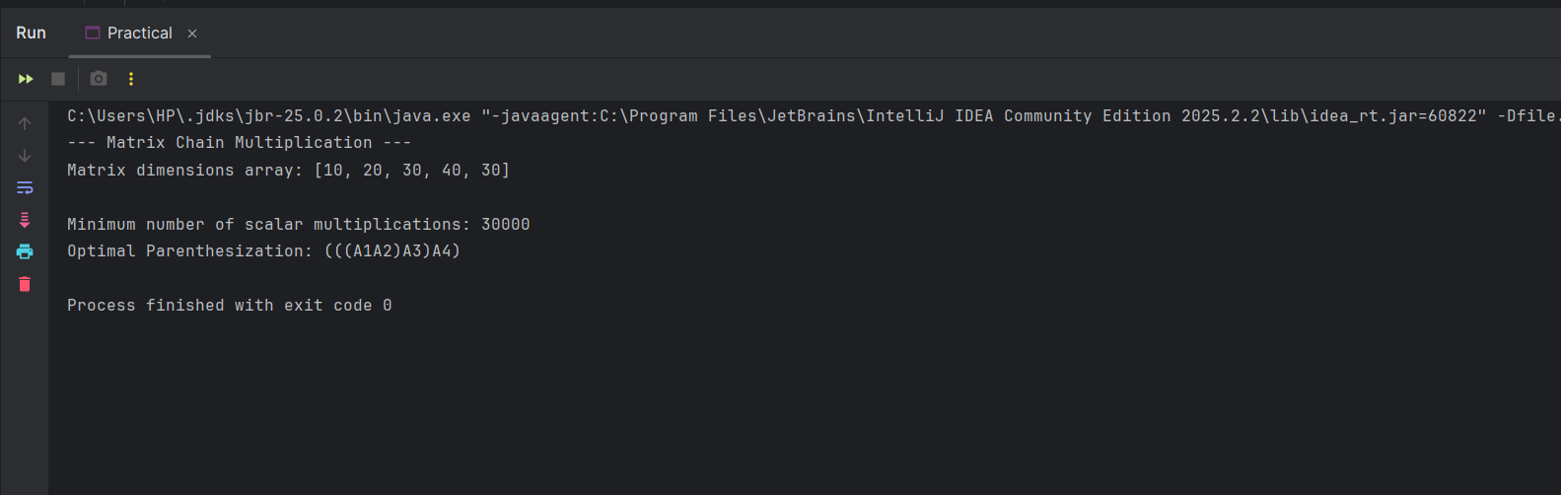

Complexity Analysis:
- Time Complexity: O(N^3), where N is the number of matrices. This is because we have three nested loops (one for the chain length L, one for the starting index i, and one for the split point k).
- Space Complexity: O(N^2) to store the two 2D arrays (m table for minimum costs and s table for split points).

Practical – 8

Dijkstra Algorithm
Aim: To implement Dijkstra's Algorithm to find the shortest path from a single source vertex to all other vertices in a given graph.
import java.util.*;

public class Practical9 {

// Function to find the vertex with minimum distance value, from
// the set of vertices not yet included in shortest path tree
private static int minDistance(int[] dist, boolean[] sptSet, int V) {
int min = Integer.MAX_VALUE, min_index = -1;

for (int v = 0; v < V; v++) {
if (!sptSet[v] && dist[v] <= min) {
min = dist[v];
min_index = v;
}
}
return min_index;
}

// Function that implements Dijkstra's single source shortest path algorithm
// for a graph represented using adjacency matrix representation
public static void dijkstra(int[][] graph, int src, int V) {
// The output array. dist[i] holds the shortest distance from src to i
int[] dist = new int[V];

// sptSet[i] will be true if vertex i is included in shortest path tree
boolean[] sptSet = new boolean[V];

// Initialize all distances as INFINITE and sptSet[] as false
for (int i = 0; i < V; i++) {
dist[i] = Integer.MAX_VALUE;
sptSet[i] = false;
}

// Distance of source vertex from itself is always 0
dist[src] = 0;

// Find shortest path for all vertices
for (int count = 0; count < V - 1; count++) {
// Pick the minimum distance vertex from the set of vertices not yet processed.
int u = minDistance(dist, sptSet, V);

// Mark the picked vertex as processed
sptSet[u] = true;

// Update dist value of the adjacent vertices of the picked vertex
for (int v = 0; v < V; v++) {
// Update dist[v] only if is not in sptSet, there is an edge from u to v,
// and total weight of path from src to v through u is smaller than current dist[v]
if (!sptSet[v] && graph[u][v] != 0 && dist[u] != Integer.MAX_VALUE
&& dist[u] + graph[u][v] < dist[v]) {
dist[v] = dist[u] + graph[u][v];
}
}
}

// Print the constructed distance array
printSolution(dist, V);
}

// A utility function to print the constructed distance array
private static void printSolution(int[] dist, int V) {
System.out.println("Vertex \t\t Distance from Source");
for (int i = 0; i < V; i++) {
System.out.println(i + " \t\t " + dist[i]);
}
}

public static void main(String[] args) {
// Let us create an example graph represented as an adjacency matrix
int[][] graph = new int[][] {
{ 0, 4, 0, 0, 0, 0, 0, 8, 0 },
{ 4, 0, 8, 0, 0, 0, 0, 11, 0 },
{ 0, 8, 0, 7, 0, 4, 0, 0, 2 },
{ 0, 0, 7, 0, 9, 14, 0, 0, 0 },
{ 0, 0, 0, 9, 0, 10, 0, 0, 0 },
{ 0, 0, 4, 14, 10, 0, 2, 0, 0 },
{ 0, 0, 0, 0, 0, 2, 0, 1, 6 },
{ 8, 11, 0, 0, 0, 0, 1, 0, 7 },
{ 0, 0, 2, 0, 0, 0, 6, 7, 0 }
};
int V = 9; // Number of vertices in the graph

System.out.println("--- Dijkstra Algorithm ---");
System.out.println("Source Vertex: 0\n");
dijkstra(graph, 0, V);
}
}

Output:
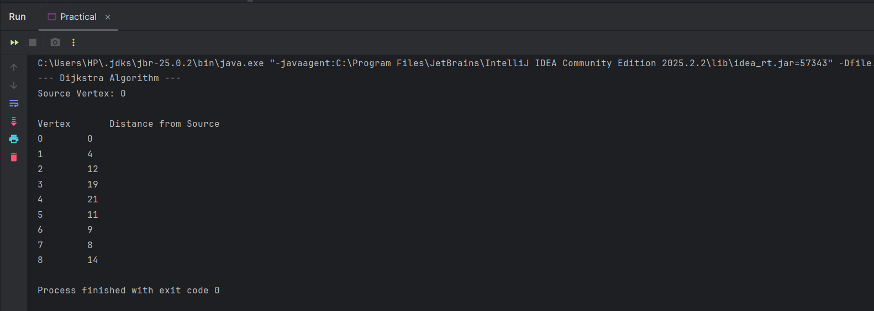

Complexity Analysis:
- Time Complexity: O(V^2) where V is the number of vertices in the graph. This is because we are using an adjacency matrix representation. If we were using an adjacency list along with a priority queue (Min-Heap), it could be optimized to O(n \log V), but an adjacency matrix is standard and acceptable for lab implementations.
- Space Complexity: O(V) to store the dist array and the sptSet (visited) boolean array. Space for the adjacency matrix itself is O(V^2).

Practical – 10

Bellman-Ford Algorithm
Aim: To implement the Bellman-Ford Algorithm to find the shortest paths from a single source vertex to all other vertices in a given graph, including graphs with negative edge weights.

Code:
public class Practical10 {

// A class to represent a connected, directed and weighted graph
static class Graph {
// A class to represent a weighted edge in graph
class Edge {
int src, dest, weight;
Edge() {
src = dest = weight = 0;
}
};

int V, E;
Edge edge[];

// Creates a graph with V vertices and E edges
Graph(int v, int e) {
V = v;
E = e;
edge = new Edge[e];
for (int i = 0; i < e; ++i)
edge[i] = new Edge();
}

// The main function that finds shortest distances from src
// to all other vertices using Bellman-Ford algorithm.
void BellmanFord(Graph graph, int src) {
int V = graph.V, E = graph.E;
int dist[] = new int[V];

// Step 1: Initialize distances from src to all other vertices as INFINITE
for (int i = 0; i < V; ++i)
dist[i] = Integer.MAX_VALUE;
dist[src] = 0;

// Step 2: Relax all edges |V| - 1 times.
for (int i = 1; i < V; ++i) {
for (int j = 0; j < E; ++j) {
int u = graph.edge[j].src;
int v = graph.edge[j].dest;
int weight = graph.edge[j].weight;
if (dist[u] != Integer.MAX_VALUE && dist[u] + weight < dist[v])
dist[v] = dist[u] + weight;
}
}

// Step 3: check for negative-weight cycles.
for (int j = 0; j < E; ++j) {
int u = graph.edge[j].src;
int v = graph.edge[j].dest;
int weight = graph.edge[j].weight;
if (dist[u] != Integer.MAX_VALUE && dist[u] + weight < dist[v]) {
System.out.println("Graph contains negative weight cycle");
return;
}
}
printArr(dist, V);
}

// A utility function used to print the solution
void printArr(int dist[], int V) {
System.out.println("Vertex \t\t Distance from Source");
for (int i = 0; i < V; ++i)
System.out.println(i + " \t\t " + dist[i]);
}
}

public static void main(String[] args) {
int V = 5; // Number of vertices in graph
int E = 8; // Number of edges in graph

Graph graph = new Graph(V, E);

// Edge 0-1
graph.edge[0].src = 0;
graph.edge[0].dest = 1;
graph.edge[0].weight = -1;

// Edge 0-2
graph.edge[1].src = 0;
graph.edge[1].dest = 2;
graph.edge[1].weight = 4;

// Edge 1-2
graph.edge[2].src = 1;
graph.edge[2].dest = 2;
graph.edge[2].weight = 3;

// Edge 1-3
graph.edge[3].src = 1;
graph.edge[3].dest = 3;
graph.edge[3].weight = 2;

// Edge 1-4
graph.edge[4].src = 1;
graph.edge[4].dest = 4;
graph.edge[4].weight = 2;

// Edge 3-2
graph.edge[5].src = 3;
graph.edge[5].dest = 2;
graph.edge[5].weight = 5;

// Edge 3-1
graph.edge[6].src = 3;
graph.edge[6].dest = 1;
graph.edge[6].weight = 1;

// Edge 4-3
graph.edge[7].src = 4;
graph.edge[7].dest = 3;
graph.edge[7].weight = -3;

System.out.println("--- Bellman-Ford Algorithm ---");
System.out.println("Source Vertex: 0\n");
graph.BellmanFord(graph, 0);
}
}

Output:
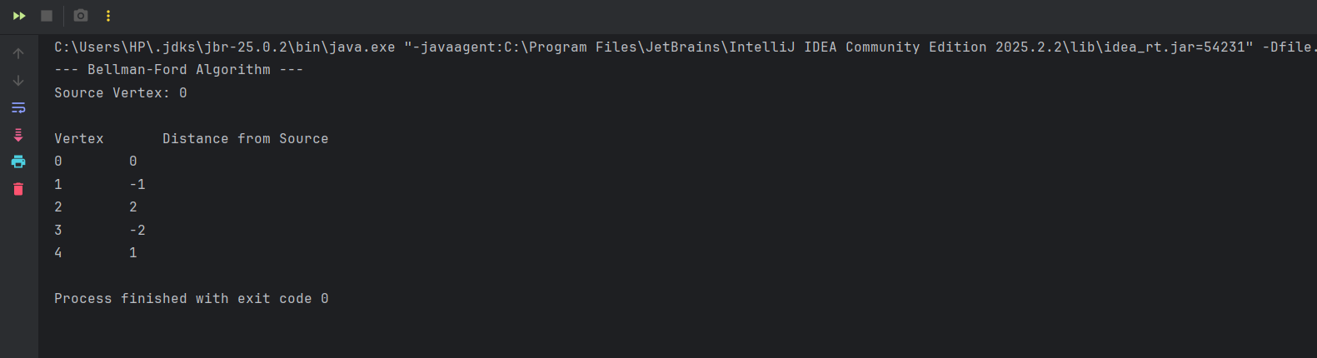

Complexity Analysis:
- Time Complexity: O(V \times E), where V is the number of vertices and E is the number of edges. This is because the algorithm iterates through all edges V-1 times to ensure the shortest path is found, even in the worst-case scenario.
- Space Complexity: O(V) to store the dist array which holds the shortest distance from the source to every other vertex.

Practical – 11

BFS and DFS
Aim: To implement and analyze the Breadth-First Search (BFS) and Depth-First Search (DFS) algorithms for traversing or searching tree or graph data structures.

Code:
package PrefixTechniques;
import java.util.*;
public class Practical {
// BFS
private int V;
private LinkedList<Integer> adj[];
Practical(int v) {
V = v;
adj = new LinkedList[v];
for (int i = 0; i < v; ++i)
adj[i] = new LinkedList();
}
void addEdge(int v, int w) {
adj[v].add(w);
}
void traverse(int s) {
boolean visited[] = new boolean[V];
LinkedList<Integer> queue = new LinkedList<Integer>();
visited[s] = true;
queue.add(s);
while (queue.size() != 0) {
s = queue.poll();
System.out.print(s + " ");
Iterator<Integer> i = adj[s].listIterator();
while (i.hasNext()) {
int n = i.next();
if (!visited[n]) {
visited[n] = true;
queue.add(n);
}
}
}
}
public static void main(String args[]) {
BFS g = new BFS(4);
g.addEdge(0, 1);
g.addEdge(0, 2);
g.addEdge(1, 2);
g.addEdge(2, 0);
g.addEdge(2, 3);
g.addEdge(3, 3);
System.out.println("BFS starting from vertex 2:");
g.traverse(2);
}
}
package PrefixTechniques;
import java.util.*;
public class Practical {
// DFS
private int V;
private LinkedList<Integer> adj[];
Practical(int v) {
V = v;
adj = new LinkedList[v];
for (int i = 0; i < v; ++i)
adj[i] = new LinkedList();
}
void addEdge(int v, int w) {
adj[v].add(w);
}
void DFSUtil(int v, boolean visited[]) {
visited[v] = true;
System.out.print(v + " ");
Iterator<Integer> i = adj[v].listIterator();
while (i.hasNext()) {
int n = i.next();
if (!visited[n])
DFSUtil(n, visited);
}
}
void traverse(int v) {
boolean visited[] = new boolean[V];
DFSUtil(v, visited);
}
public static void main(String args[]) {
Practical g = new Practical(4);
g.addEdge(0, 1);
g.addEdge(0, 2);
g.addEdge(1, 2);
g.addEdge(2, 0);
g.addEdge(2, 3);
g.addEdge(3, 3);
System.out.println("DFS starting from vertex 2:");
g.traverse(2);
}
}

Output of BFS:
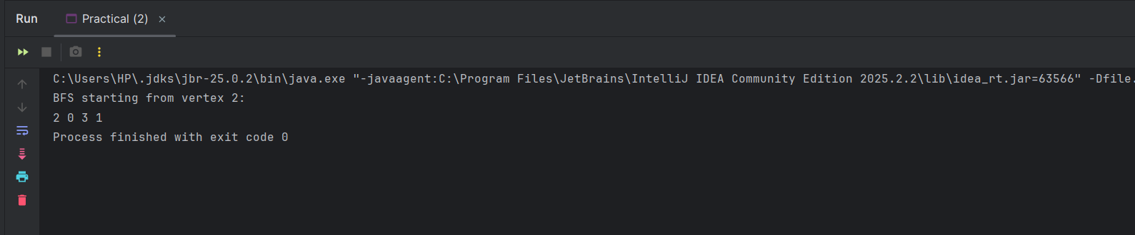

Output of DFS:
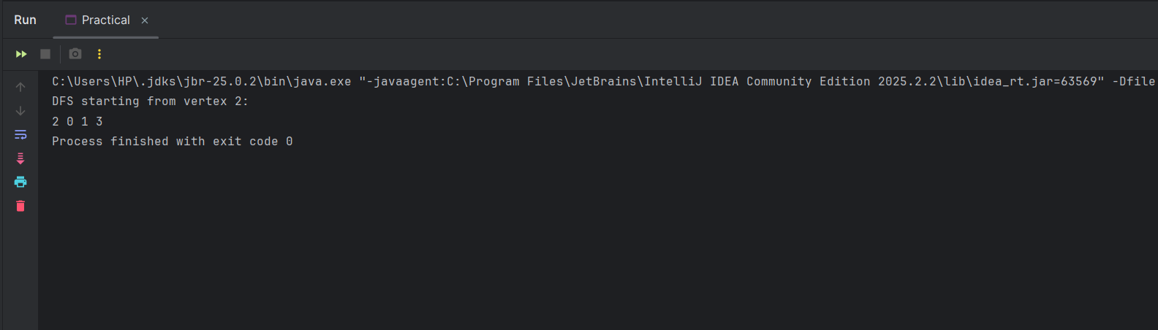

Complexity Analysis:
- Time Complexity: O(V + E), where V is the number of vertices and E is the number of edges. This is because the algorithm visits every vertex once and explores every edge exactly once (or twice for undirected graphs) to ensure the entire reachable graph is traversed.
- Space Complexity: O(V) to store the visited array and the auxiliary data structure (a Queue for BFS or a Stack/Recursion Call Stack for DFS) which holds the vertices.

Practical – 12

N - Queen Problem
Aim: To solve the N-Queen Problem using backtracking, ensuring that N queens are placed on an N \times N chessboard such that no two queens attack each other.

Code:
public class NQueen {
final int N = 4;

void printSolution(int board[][]) {
for (int i = 0; i < N; i++) {
for (int j = 0; j < N; j++)
System.out.print(" " + (board[i][j] == 1 ? "Q" : ".") + " ");
System.out.println();
}
}

boolean isSafe(int board[][], int row, int col) {
int i, j;
// Check this row on left side
for (i = 0; i < col; i++)
if (board[row][i] == 1) return false;

// Check upper diagonal on left side
for (i = row, j = col; i >= 0 && j >= 0; i--, j--)
if (board[i][j] == 1) return false;

// Check lower diagonal on left side
for (i = row, j = col; j >= 0 && i < N; i++, j--)
if (board[i][j] == 1) return false;

return true;
}

boolean solveNQUtil(int board[][], int col) {
if (col >= N) return true;

for (int i = 0; i < N; i++) {
if (isSafe(board, i, col)) {
board[i][col] = 1; // Place queen
if (solveNQUtil(board, col + 1)) return true;
board[i][col] = 0; // Backtrack
}
}
return false;
}

void solve() {
int board[][] = new int[N][N];
if (!solveNQUtil(board, 0)) {
System.out.print("Solution does not exist");
return;
}
printSolution(board);
}

public static void main(String args[]) {
NQueen Queen = new NQueen();
Queen.solve();
}
}

Output:
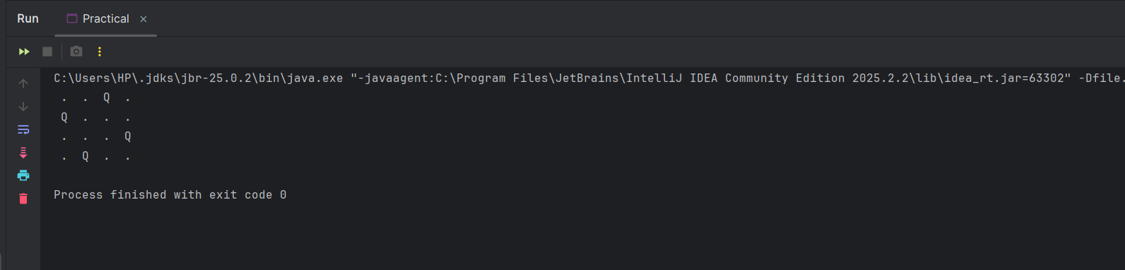

Complexity Analysis
- Time Complexity: O(N!), where N is the number of queens and the size of the board. This is because the algorithm explores all possible placements of queens row by row, and for each row, the number of available options decreases as previous queens are placed, following a factorial-like growth in the worst-case scenario.
- Space Complexity: O(N^2) to store the N \times N board array that represents the state of the chessboard. (Note: The recursion stack depth is O(N)).

Practical – 13

Sum of Subsets
Aim: To solve the Sum of Subsets problem using backtracking to find all subsets of a given set of n positive integers whose sum is equal to a specified target value K.

Code:
import java.util.*;

public class SumOfSubsets {
static void findSubsets(int[] set, int target, int index, List<Integer> current, int currentSum) {
// If current sum matches target, print the subset
if (currentSum == target) {
System.out.println(current);
return;
}

// If sum exceeds target or no more elements left
if (currentSum > target || index == set.length) {
return;
}

// Include the current element
current.add(set[index]);
findSubsets(set, target, index + 1, current, currentSum + set[index]);

// Exclude the current element (Backtrack)
current.remove(current.size() - 1);
findSubsets(set, target, index + 1, current, currentSum);
}

public static void main(String[] args) {
int[] set = {10, 7, 5, 18, 12, 20, 15};
int target = 35;
System.out.println("Subsets with sum " + target + ":");
findSubsets(set, target, 0, new ArrayList<>(), 0);
}
}

Output:
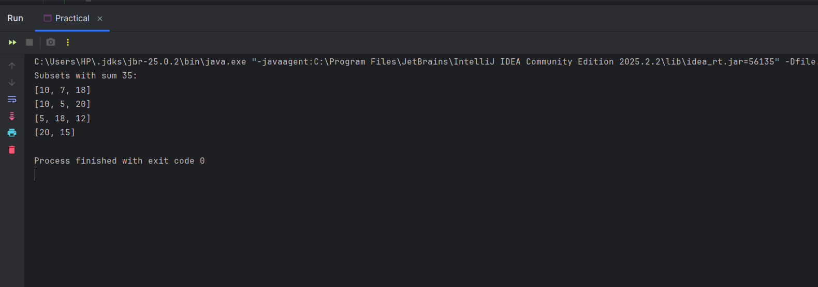

Complexity Analysis:
- Time Complexity: $O(2^n)$, where $n$ is the number of elements in the set. This is because each element has two possibilities (either included in the subset or excluded), leading to a state-space tree with a total of $2^n$ nodes in the worst-case scenario.
- Space Complexity: $O(n)$ to store the recursion stack and the current subset list, which grows linearly with the number of elements in the input set.

Practical – 14

Naïve String Matching
Aim: To implement and analyze the Naive String Matching algorithm to find all occurrences of a pattern within a given text by shifting the pattern one by one.

Code:
public class NaiveStringMatching {
public static void search(String text, String pattern) {
int n = text.length();
int m = pattern.length();

// Loop to slide pattern over text one by one
for (int i = 0; i <= n - m; i++) {
int j;

// Check for pattern match at current index i
for (j = 0; j < m; j++) {
if (text.charAt(i + j) != pattern.charAt(j)) {
break;
}
}

// If pattern matches the text at current index
if (j == m) {
System.out.println("Pattern found at index " + i);
}
}
}

public static void main(String[] args) {
String text = "AABAACAADAABAAABAA";
String pattern = "AABA";
System.out.println("Text: " + text);
System.out.println("Pattern: " + pattern);
search(text, pattern);
}
}

Output:
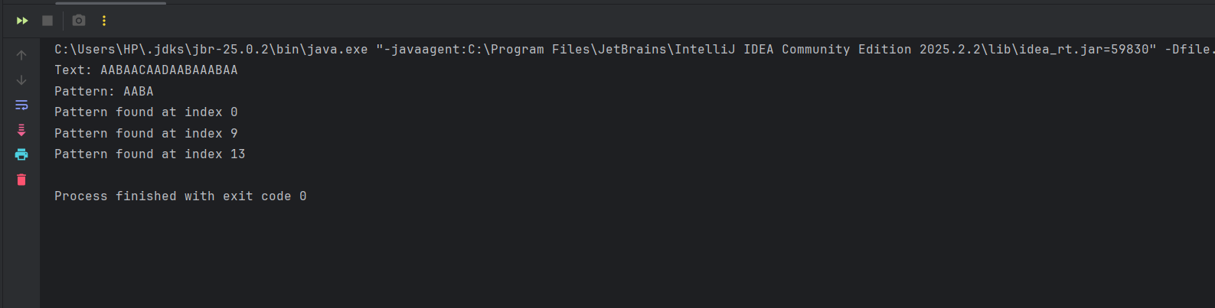

Complexity Analysis:
- Time Complexity: $O(m \times (n - m + 1))$, where $n$ is the length of the text and $m$ is the length of the pattern. This is because in the worst-case scenario (like searching "AAAA" in "AAAAA"), the algorithm compares the pattern characters against the text at every possible shift position.
- Space Complexity: $O(1)$ as the algorithm only requires a constant amount of extra space for integer variables like indices, regardless of the input size.

